Game server and billing system(Taiwan) communicate interface

- Topology
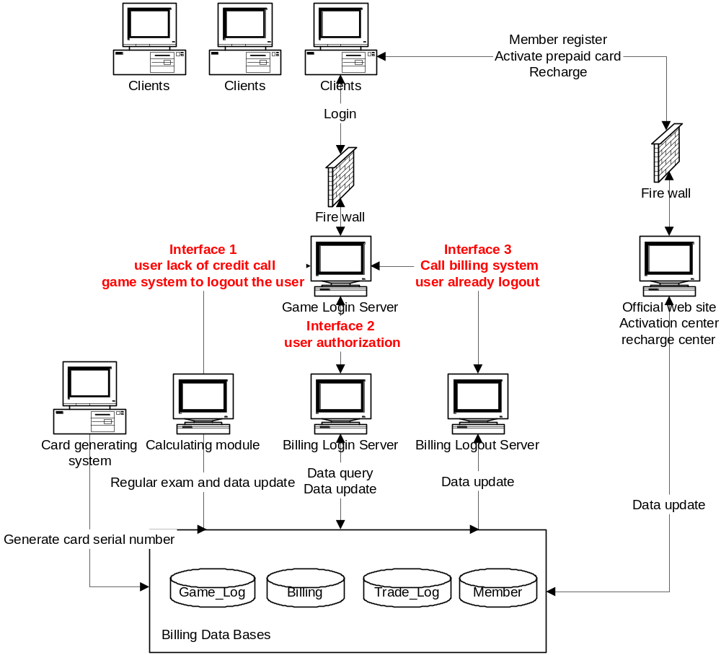
- Work flow description
  - Login procedure (Interface 2)
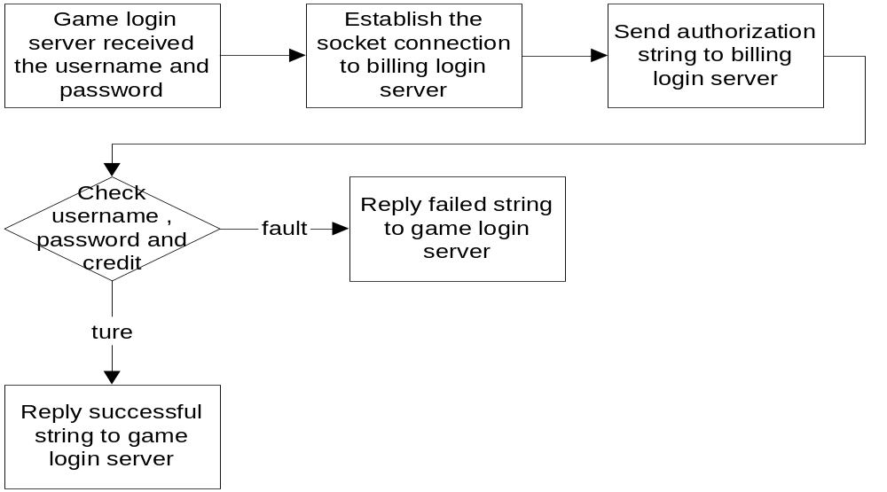

Socket connection (Not Winsock)：
- Host name loginserver.x-legend.com.tw
- Port 7777

Authorization string format ： auth##username##password##gametype##
- auth ： key word for authorization
- username ： member user name
- password ： member pass word
- gametype ： game identity number (knight online is 1)
ex. auth##john##john123##1##

Failed and Successful string format ：
UPCheck##AcceptOrNot##
- UPCheck ： username and password status
0：username or password is error.
1：username and password is correct.
- AcceptOrNot ： Is the user allowed to login to game server?
0：lack of credit， login to game server is denied
1：allow to login to game server
2：the credit is enough but the billing rule setting is not pay per hour，please show following Chinese message to client “你目前的計費方式不是計時制，請到儲值中心繼續月費儲值或修改計費方式為計時制。”
3：Socket connection is full，please retry again
ex：0##0## username or password is error，please retry again.
1##0## username and password is correct but lack of credit，login to game server is denied.
1##1## username and password is correct and the credit is enough ，allow to login to game server.
1##2## show message to user ，remind him to change it’s billing rule setting to “pay per hour”.
1##3## please retry login again.

  - Logout procedure (Interface 3)
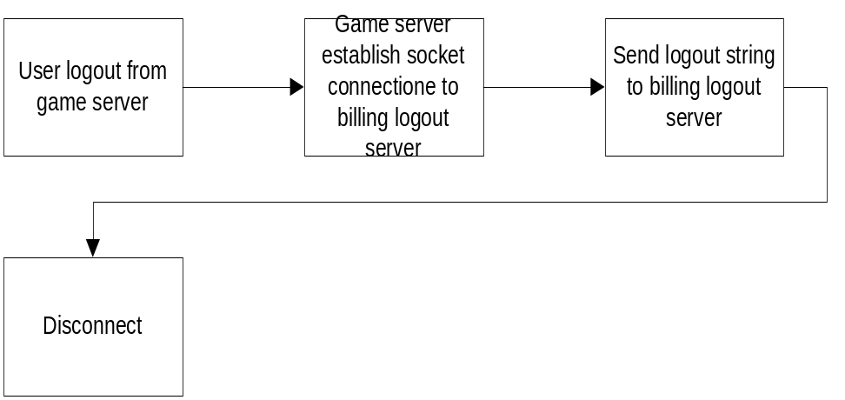

Socket connection：
- Hostname：logoutserver.x-legend.com.tw
- port：6666

Logout string format：
logout##Username##gametype##
- logout ： key word for logout
- username ： member user name
- gametype ： game identity number (knight online is 1)
ex. logout##john##1##

No return message
  - Calculating module procedure (Interface 1)
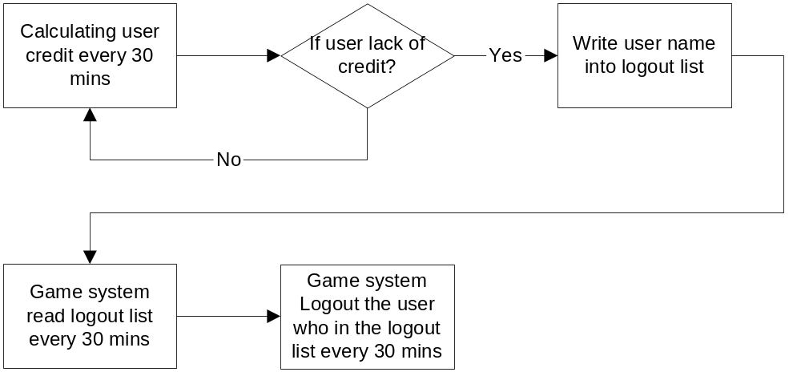

Logout list：
- Description ：A data table for saving non-credit members’ username.
- Data schema：
PK | Column name | Data type | Description | Null
 | ID | Int | Serial number | No
P | UserName | Char (20) | The non-credit members’ username | No
- Database Setting：
  - Host IP：192.168.1.140
  - Database name ： Logout_list
  - Table name ：Logoutlist

- Billing login server simulation program installation
  - Description of billing system
The X-legend billing system is written by Java. We use the multi-thread to process individual users’ connection. In present the billing system can process more than 1,200 users’ connection in one minute. The higher hardware spec. the more users’ connection can be processed.
The integration of billing system and game system can process information exchange via socket connection and database.
The X-legend billing system architecture will hide the billing login server in back of the firewall and game login system. This architecture design prevent the billing login server from directly contact with clients. The user data will more safe.
  - Simulation program installation
    - Install Java 2 Platform, Standard Edition version 1.4.0_01
Download site：
http://java.sun.com/j2se/
    - unzip file X-Billing.zip
    - move directory to c:\
    - click file c:\X-Billing\loginserver.bat for running Login Server
    - click file c:\X-Billing\logoutserver.bat for running Logout Server

